Seoul Public Notice #2022-592
Application for Seoul Fintech Lab 2022
The Seoul Fintech Lab is pleased to announce the opening of the application for our 2022 fintech startup incubation program. Promising Fintech startups are encouraged to apply for the Seoul Fintech Lab Incubation Program which includes the opportunity to tap on the Seoul Fintech Lab’s global network and a maximum of three years of exclusive space.

March.2nd, 2022
Mayor of Seoul
The Seoul Fintech Lab is established and funded by the Seoul Metropolitan Government of South Korea Since 2019, We support 86 fintech startups including 17 foreign startups with our incubation program. It aims to help accelerate Fintech companies’ growth with its global network of over 300 partners and mentors which include highly experienced investors, entrepreneurs and regulators.
You will have access to our invaluable global networks which include highly experienced investors, entrepreneurs and regulators that will help lay the foundations to your future conquest of the Asian markets.
Furthermore, we offer a wide range of exclusive services to help drive your business growth, including intensive incubation programs, comprehensive localization consulting and investment roadshows with well-connected Korean investors.
Lastly, we will provide an office space up to 1+1+1 years max (contract is renewed through annual evaluation). For example, May of 2023, we will review your progress and achievements. If deemed satisfactory, we will renew the contract. The period can be extended up to 1 year.
Seoul Fintech Lab has 33 local corporate partners in seven sectors including banking, asset management, investment, law and tax. Our dedicated partners will support you in your effort to localize your services.

Please refer to the following for more information.
- Timeline
  - Application Period: March 2nd, 2022 ~ March 31th, 2022, 23:59(KST)
  - Application Link: Seoul Fintech Lab Website
www.seoulfintechlab.kr
  - 1st Round Paper Review: April 6th, 2022 ~ April 7th, 2022
  - 1st Round Results Announcement: April 8th, 2022 by individual E-mail
  - 2nd Round In-Person Presentations: April 12th, 2022~ April 13th, 2022
  - Final Results Announcement: April 15th, 2022 by individual E-mail
  - Signing the Agreement for Seoul Fintech Lab Startup: May 2nd, 2022 ~
  - Orientation for Final Selected Startups: May 9th, 2022
  - Move-In Period: ~ July, 31st 2022
    - If you selected as final, you must move in by July, 31st 2022.
    - However, if you are difficult to move in by July, 31st, it can be adjusted through prior discussion. The detailed date and related documents must be submitted in advance.

- Evaluation – The dates are subject to change.
    - 1st Round Paper Review: April 6th, 2022 ~ April 7th, 2022
    - It will be evaluated with criteria of below based on the submitted documents.
      - Business Status and Motivation (15)
      - Financial Status (15)
      - Business Model (25)
      - Differentiation of Business Item (15)
      - Possibility of Global Expansion (10)
      - Teamwork Competency (20)
  - 1st Round Results Announcement: April 8th, 2022 by individual E-mail
  - 2nd Round In-Person Presentations: April 12th, 2022~ April 13th, 2022
    - Pitching for 7 min, Q&A for 8 min. You can present either in English or Korean.
    - It will be evaluated with criteria of below based on your pitch.
      - Possibility of Realizing the Innovation (20)
      - Possibility of Realizing the Business Strategy (30)
      - Potential of Global Growth (15)
      - Possibility of Attracting Investment (15)
      - Expected effects such as employment etc. (20)
    - If you are not able to pitch in person at Seoul Fintech Lab, it can be adjusted to a conference call through prior discussion.
  - Final Results Announcement: April 15th, 2022 by individual E-mail
    - The highest score will be selected based on the total score: 40% of 1st round evaluation score + 60% of 2nd round evaluation score.

- Applicant Eligibility (All)
  - Fintech startups which plan to expand into the Asian markets, or to begin with South Korea in these fintech relevant businesses: digital/mobile banking, payments, remittance, crowdfunding, financial data analysis and management, reg-tech, insure-tech, financial security, blockchain based financial services, robo-advisory, prop-tech etc.
  - Fintech startups which have registered business in overseas as of the announcement date (March 2nd, 2022)
** Business registration in Korea is not a necessary requirement and Seoul Metropolitan will not support Visa for application to the Seoul Fintech Lab Incubation Program.
** Those who are getting supports for an office space by Seoul Metropolitan Government or the central/local government of Korea, will be excluded from the list of applicants as of the signing date (May 2nd, 2022). However, those who gives up the project, or the project term ends before the announcement date can apply.

- Program Information
  - Residency Period: May. 2nd. 2022 – May. 1st. 2023 (12months)
    - The residency period can be extended through mid-term/extension evaluation results up to 1+1 year more (3 years in total)
    - There is a possibility that some fees can be charged from July 2022. (According to Article 25(1) of the Enforcement Rule of the Seoul Metropolitan Government’s Ordinance on the Promotion of the Financial Industry)
  - Program Support
    - Office Space, Accelerating Programs; Mentorship with local experts, Startup Education & Training, Demo-day & IR, Marketing, Global Expansion Supporting etc.

- Documents List
  - (Mandatory) Business Plan (should include below, free-form, We accept this document written in English or Korean only.)
    - Company information and status
- Reasons for the application to the program
- Market analysis and competitive positioning including South Korea and globally
- Business model and competitive advantages
- Growth roadmap including hiring plan in South Korea and overseas
- Financial status including fund raising, sales etc.
- Detailed move-in date to the Fintech Lab
- Number of employees who will work in the office of Seoul Fintech Lab
  - (Mandatory) A copy of Business Registration Documents that proves itself to be a foreign enterprise from the Government.
  - (Mandatory) Career Profile of Team Members (Free-form, PDF File only)
  - (Mandatory) Financial Statement for the last 3 years
  - (Optional) Company Introduction File as a PDF
  - (Optional) Certificate of Registration of a Foreign-Invested Enterprise
  - (Optional) Certificate of Establishment of Local Branch in Korea, etc.
    - If you don’t have this optional document above, please submit an official letter from headquarters that includes the approval of the Korean office operation.
  - (Optional) Invest Attraction Agreement after the startup incorporated

- Seoul Fintech Lab Location
  - The Seoul Fintech Lab is located at WeWork Yeouido Station in Seoul, South Korea.
    - Address: 8F, O2 Tower, Uisadang-daero 83, Yeongdeungpo-gu, Seoul, Republic of Korea (07325)
    - Accessibility
      - Subway line 5 and 9, Yeouido Station
      - 1 hour by car from Incheon International Airport
    - Location on Google Map :https://goo.gl/maps/xMEqGbkeaZxcuynTA
 | 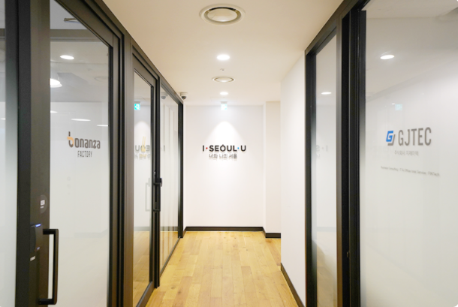
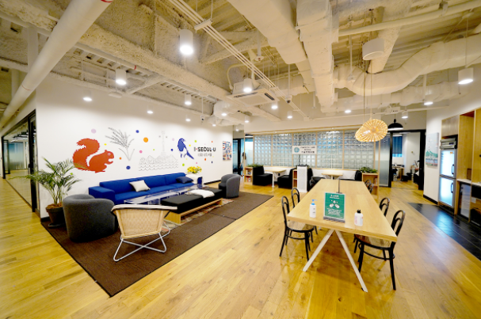 | 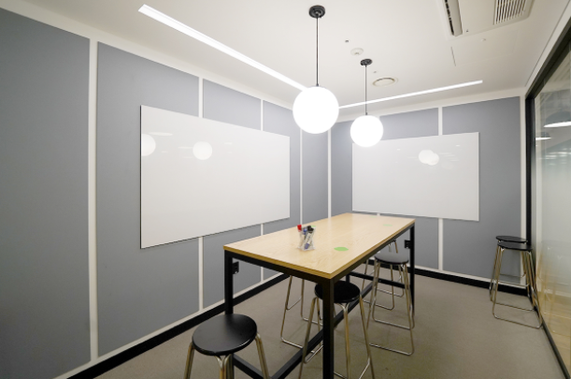
<Spaces at Seoul Fintech Lab>

- NOTICE
- Your application will not be assessed if any required document is not submitted.
- Upon the confirmation of any fraudulent act including the intentional omission of information, provision of false information and forgery of required documents, the application will be void.
- Violation of this notice or information omission in the application documents detected after any successful application will result in serious consequences, including forced eviction, criminal prosecution etc.
    - Please note that evaluation scores and contents will not be disclosed, and application materials will not be returned.
    - All the dates, which are not stated separately, will be the announcement date.

- Contact Information
  - Email: contact@seoulfintechlab.kr
  - TEL: +82 2-786-0669 / +82 2-786-0665

The end.

